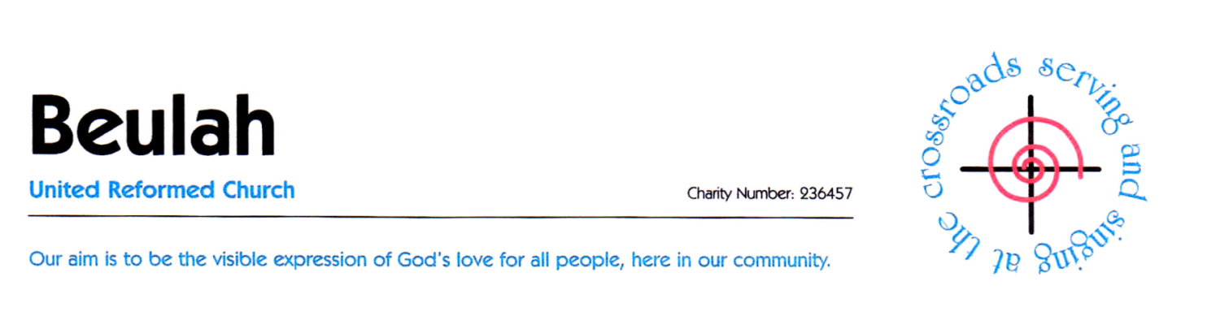
BRIGHT NOW - the campaign for fossil free Churches

ACT NOW FOR A BRIGHTER FUTURE

You are warmly invited to join us for our evening of
Workshop, Discussion and Refreshments
led by James Buchanan from Operation Noah
Saturday, 29th September at 7.00pm
Canolfan Beulah, Rhiwbina CF14 6LX

Operation Noah is a Christian charity working with the Church to inspire action on climate change. It launched the Bright Now campaign in 2013, which calls on UK Churches to divest (disinvest) from fossil fuels and invest in clean alternatives. Nearly 1,000 institutions around the world with more than $6 trillion of assets under management have now made divestment commitments.
In order to meet the UN Paris Agreement targets we know that the vast majority of fossil fuel reserves need to stay in the ground, yet oil and gas companies continue to pursue business plans leading to dangerous levels of global warming, with devastating consequences for humanity.
The Bright Now campaign is inviting Churches to follow the lead of the World Council of Churches, the Church of Ireland and the URC Synod of Scotland in committing to full divestment from fossil fuels.

‘People of conscience need to break their ties with corporations financing the injustice of climate change’
Desmond Tutu (former Archbishop of Cape Town and Nobel Peace Prize winner)

James Buchanan is the Bright Now Campaign Manager for Operation Noah. He previously worked at Christian Aid, CAFOD and for the Church of England Pilgrimage2Paris 2015.

We are very grateful to have James come to Cardiff to speak about the role that Churches can play in supporting the clean energy transition, and we would be pleased if you could join us.

RSVP richardeileen2009@hotmail.co.uk Further details 02920 624967

